

##### A

**MINI PROJECT REPORT ON**

**“IoT Based Patient Monitoring System”**

FOR PARTIAL FULFILLMENT OF THE REQUIREMENTS FOR THE

MINI PROJECT SUBJECT OF

T.E. E&TC – 2019 COURSE, SPPU, PUNE

By

##### Ganesh Kavale T190053081

**Tejaswini Jadhav T190053108**

##### GUIDE

**Ms. Sakshi Hosamani**

**DEPARTMENT OF**

**ELECTRONICS AND TELECOMMUNICATION ENGINEERING PUNE INSTITUTE OF COMPUTER TECHNOLOGY**

**PUNE – 43**

**ACADEMIC YEAR: 2021 - 2022**

**Department of Electronics and Telecommunication Engineering**

#### Pune Institute of Computer Technology, Pune – 43

CERTIFICATE

This is to certify that the Mini Project Report entitled

IoT Based Patient Monitoring System

has been successfully completed by

##### Ganesh Kavale T190053081

Tejaswini Jadhav T190053108

Is a bonafide work carried out by them under the supervision of Ms. Sakshi Hosamani and it is approved for the partial fulfillment of the requirements for the Mini Project of T.E. E&TC – 2019 Course of the Savitribai Phule Pune University, Pune.

Ms. Sakshi Hosamani Dr. Mousami Munot

Project Guide HOD, E&TC

Dept. of E&TC

Place: Pune Date:

### ACKNOWLEDGEMENT

It’s our pleasure to express sincere and heartiest thanks to our Mini Project Guide Ms. S.M. Hosamani for her valuable guidance, encouragement and support for the accomplishment of Project Execution & Report Writing.

We also express our sincere thanks to Principal R. Sreemathy and Head of the Department Dr. Mousami Munot for their constant encouragement and motivation for accomplishment of mini project by expressing their guidelines regarding importance of mini project in developing our career.

We are thankful to all the group members of our mini project for their valuable contribution. We are thankful to all those persons who directly or indirectly helped us in completion of this project proposal.

Ganesh Kavale

Tejaswini Jadhav

##### ABSTRACT

Now-a-days Health-care Environment has developed science and knowledge based on

Wireless-Sensing node Technology oriented. Patients are facing a problematic situation of unforeseen demise due to the specific reason of heart problems and attack which is because of nonexistence of good medical maintenance to patients at the needed time. This is for specially monitoring the old age patients and informing doctors and loved ones. So, we are proposing an innovative project to dodge such sudden death rates by using Patient Health Monitoring that uses sensor technology and uses internet to communicate to the loved ones in case of problems. This system uses Temperature and heartbeat sensor for tracking patients’ health. Both the sensors are connected to the NodeMCU ESP8266. To track the patient health in turn interfaced to a LCD display and wi-fi connection to send the data to the web-server (Wireless sensing node). In case of any abrupt changes in patient heart-rate or body temperature alert is sent about the patient using IoT. This system also shows patients temperature and blood Pressure tracked live data with timestamps over the Internetwork. Thus, Patient health monitoring system based on IoT uses internet to effectively monitor patient health and helps the user monitoring their loved ones drom work and saves lives.

Ganesh Kavale

Tejaswini Jadhav

List of figures:

|  |  |  |
| --- | --- | --- |
| Sr. No  1 | Figure number and Figure caption  NodeMcuEsp8266 | Page no.  3 |
| 2 | MAX30100 (Spo2/bpm) | 3 |
| 3 | DHT – 22 | 7 |
| 4 | DS18B20 | 7 |
| 5 | 16 Hhz Oscillator | 8 |
| 6 | Potentiometer | 8 |
| 7 | Simulation | 9 |
| 8 | PCB Model | 10 |
| 9 | Greber schematics | 11 |
| 10 | Block Diagram | 12 |

List of tables:

Sr. No

Table number and Table caption Page no.

1 Total Bill of the Project 13

### CONTENTS

Abstract i

List of Figures ii

List of Tables iii

Abbreviations iv

1. Introduction 1-10
   1. Background and Context 1
   2. Relevance 2
   3. Literature Survey 3
   4. Motivation 6
   5. Aim of the Project 7
   6. Scope and Objectives
   7. Technical Approach
2. Block Diagram
   1. Theoretical background
   2. Block diagram
   3. Flow chart Algorithm
3. System Design
4. Implementation, Testing and Debugging
5. Results and discussion Conclusions and Future Scope Bill of Material

References Datasheets

**Feasibility report**

**Title: IoT Based Patient Heath Monitoring System**

**Group members:**

1. Ganesh Kavale 2) Tejaswini Jadhav

|  |  |  |  |  |  |  |
| --- | --- | --- | --- | --- | --- | --- |
| **Tools required** | | **Testing possibility** | | **Controller** | | **Cost** |
| 1. **Drilling Machine** 2. **Soldering Quipments** 3. **Tools Required for PCB fabrications** 4. **Screw Driver and Screws** | | **Yes Yes**  **Yes Yes** | | 1. **NodeMCU ESP8266** 2. **LCD dISPLAY**   **3. MAX 30100**   1. **Temperature sensor DHT 22** 2. **Connecting wires** 3. **Zero PCB** 4. **Breadboard** | | **Rs. 360**  **Rs. 240**  **Rs. 125**  **Rs. 300**  **Rs. 40** |
| **Software**   1. **Proteus 8** 2. **Arduino Uno IDE** 3. **Circuito.io** 4. **Think speak** 5. **Blynk app** | | **Software Yes**  **Yes**  **Yes**  **Yes**  **Yes** | | **N.A.** | | **N.A.** |
| **Tools available campus or outside** | **within** | **Sensors required** | | **Signal conditioning if any** | |  |
| **All Tools were available within the campus** | | **N.A.** | | **N.A.** | | **N.A.** |
| **Applications if any** | | **PCB design fabrication** | **and** | **Datasheets/ application notes available** | |  |
|  | | **In-house facility was utilized** | | **Available** | | **N.A.** |
| **Mechanical design** | | **Enclosure design** | | **Demonstration** | |  |
| **Required** | | **Required** | | **The Project Physically Demonstrated** | **was** | **N. A** |

**Title of project:** IoT Based Patient Monitoring System

**Electric specification Mechanical specification**

Temperature Range

DHT -> -40 to + 125 degree Celsius

NodeMcu ESP8266– 3.3V To 5V

Power Supply - 5V

**Group members:**

|  |  |
| --- | --- |
| **T190053081** | **Ganesh Kavale** |
| **T190053108** | **Tejaswini Jadhav** |

# CHAPTER 1

## Introduction

#### Background

Our project presents the development of patient monitoring system for two primary vital signs of body temperature and respiratory rate. The monitoring system was implemented in IoT platform and designed using NodeMCU ESP8266 Module and MAX30105 sensor. Each module use temperature sensors LM35. The purposes of this project are to design patient monitoring system that can detect the vital signs level, analyses the level of vital signs according to the patient age, provide alert for abnormal condition and also displayed the results wirelessly through android apps. This project would minimize the work load for nurses in hospital and provide much convenient method in monitoring status of each vital signs for every patient in the ward. Conventional method which requires nurse to visit every patient to record vital signs measurement is time consuming. With this system, nurses can monitor the patient status through android apps installed into any android device. Nurses or doctors can also review the previous vital sign status by downloading the data from the cloud in the excel format. Comparison on the two vital signs level obtained from this system with standard measurement equipment or manual observation shown almost similar results.

#### Relevance

As we belong to Electronics and telecommunication department there are various modern technologies implemented using our fundamentals. From there we have selected a project named IoT Based Patient Health Monitoring System. The electronic and communicating component included in our project are as follows:

1. NodeMcu ESP8266: Nodemcu is an open source iot based microcontroller which runs on Wi-Fi soc from espressif system. The second functioning of it is communicating through the wifi based channel through the whole bandwidth for the transmission or reception of whole data. Its frequency range is 2.4GHz it plays a major role for completing our fundamentals related to communication engineering.
2. MAX30100: Max30100 is a Blood pressure and oxygen monitoring sensor which includes monitoring of the oxygenated and deoxygenated blood in the person body accordingly it will give the output for the Spo2/Bpm. It is aa highly reliable sensor with precise output and dependent for many medical applications for the field of medical engineering. It is also a form of development in Engineering.
3. **DS18B20: T**he **DS18B20**is a 1-wire programmable Temperature sensor from maxim integrated. It is widely used to measure temperature in hard environments like in chemical solutions, mines or soil etc. The constriction of the sensor is rugged and also can be purchased with a waterproof option making the mounting process easy. It can measure a wide range of temperature from **-55°C to +125°** with a decent accuracy of **±5°C**. Each sensor has a unique address and requires only one pin of the MCU to transfer data so it a very good choice for measuring temperature at multiple points without compromising much of your digital pins on the microcontroller. **So it plays a major role for completing the fundamentals related to temperature sensing of aa human body temperature**
4. DHT-22: The DHT22 is a basic, low-cost digital temperature and humidity sensor. It uses a capacitive humidity sensor and a thermistor to measure the surrounding air and spits out a digital signal on the data pin (no analog input pins needed). It's fairly simple to use but requires careful timing to grab data. The only real downside of this sensor is you can only get new data from it once every 2 seconds, so when using our library, sensor readings can be up to 2 seconds old.

The basic need for the sensing for the room temperature is done using DHT 22

#### Literature Survey

The study of “IoT” was comprehensive and montages relations and constraints. The main goal of “IoT” is to ensure that, in conjunction with “electronic sensor” devices, Internet-based communications and the sending and reception of information are conventionally accessible. The IoT main aim, though, is to incorporate organizations, mechanization so that messages can be transmitted without interruptions, compared to software creation; the start of the programmed is the most frequently recycled sensors with accelerometers, compression-embedding camps such as the “MCUS, MPUs”. The initial opinion for the “IoT phase is divided into criteria, specifications and implementation” is comparable to software development overall. The WSN is a significant part of IoT, and it also plays an important role in its healthcare applications. They are known for their high-end and miscellany wireless control systems over other regular devices. Working on the WSN for pulse rates and oxygen saturation was emphasized by Rotariu and Manta in 2012. On the other hand, and ECG and blood pressure sensors mounted on the mobile telephone in 2016. With the IoT approach in the health analogy, the wireless network improves. Tan etal used Wi-Fi technology for its 2012 work in the control area to relay messages on different body functionality, such as blood pressure, pulse rate, body temperature and oxygen saturation.

* Blood Pressure Monitoring System: High blood pressure shows the heart pumping through the body powerfully. The method of IoT promotes the diagnosis and treatment of health problems, including blood pressure (BP), hemoglobin (HB), levels of blood sugar and abnormal cell growth. An IoT system for blood pressure, diabetes and obesity treatment.
* Body Temperature Monitoring: Body temperature control and tracking is an essential component in health applications. The homeostasis change depends on the temperature of the body, based on the m-IoT principle. On the top of an IoT unit, the body temperature control device is centered on the home port. It supports the control and calculation of the temperature infrared detection and RFID module.
* Oxygen Saturation Monitoring System: The Pulse oximeter is used to measure oxygen in the blood continuously. The use of IoT with pulse oximetry is useful for technical applications. The benefit of IoT-based pulse oximetry is addressed by coAP-based health care system studies. Ninin shows the function of the Wrist OX2 oximeter machine. This system is wired to Bluetooth and links the sensor directly to Monere. To track remote patients, an IoT-based norm and low-pulse oximeter is used.

#### Motivation

#### The health monitoring system has become popular these days due to uniqueness and

#### diversified usage in the medical field. Everyday many lives are affected because the diseases

#### are not timely and properly diagnosed so we didn't get a chance to provide medical help.

#### To deal with these types of situations, this system will help to monitor a patient's certain

#### parameters and predict the patient's condition from time to time. This system is user friendly

#### and reduces the human efforts. Internet Of Things (IOT) based smart health monitoring

#### system will help to measure various health-related parameters like body temperature, pulse,

#### ECG, blood pressure etc. which will help to predict diseases. System will consist of a website

#### which will help to monitor patient's health and also data can be shared with a particular

#### doctor if required by URL.

#### Aim of the Project

#### The aim of patient monitoring is to give warning of early or dangerous deterioration and

#### to achieve this by obtaining an optimal compromise involving many design factors,

#### clinical, engineering and economic. IoT enables healthcare professionals to be more

#### watchful and connect with the patients proactively. Data collected from IoT devices can

#### help physicians identify the best treatment process for patients and reach the expected

#### outcomes.

#### Scope and Objectives

#### Scope:

#### Looking at various needs in the medical field for the engineering we have seen need for social distancing looking forward we have seen that our project clears all the aspects required for the same looking forward to it it has many more advancements that can help our project to rise and make it a as a part of Helping hand in the medical field which will also help is there is any other rise of such disaster named COVID – 19.

#### There can more advance engineering applied to this project by adding many more applications but ass there are some limitations for the pins in nodemcu we need to find some other microcontroller for it. Many hospitals have earlier adopted it on a large scale that has brought a change towards the flexibility in managing the patients from anywhere and with proper precise instruction.

#### Objective:

#### Main objective of our project is to create modernization in the field of Medical and creating a

#### well developed area which can bring monitoring and controlling of a patient through anywhere

#### which can bring electronics engineering in working with the medical department as we have

#### seen the effect of Covid – 19 which had brought the whole world to an end. At last it was seen

#### each and every person in contact with the covid affected person was facing the crises

#### Looking the point of social distancing we found that our project would be presented as a

#### Helping hand towards the crises caused due to social distancing any patient would be easily

#### monitored from anywhere buy using IOT as a part of communication. Here NodemcuEsp

#### 8266 also play the major role for the same as a microcontroller

#### NodeMCU is an open source platform based on ESP8266 which can connect objects and let transfer using the Wi-Fi protocol. In addition, by providing some of the most important features microcontrollers such as GPIO, PWM, ADC, and etc, it can solve many of the project's needs.

# CHAPTER 2

# Design Specifications

#### Introduction

Currently, the COVID-19 pandemic is one of the major global issues faced by health organizations. As of November 19, 2020, the total number of people worldwide confirmed to have been infected with SARS-COV-2 is more than 56.4 million, while the total number of fatalities from the coronavirus is more than 1.35 million, thereby proving that COVID-19 cases are surging worldwide. In Bangladesh, presently, there are a total of 445,281 positive COVID-19 cases, while the coronavirus fatality toll is 6350 as of November 21, 2020. COVID-19 patients have several symptoms, such as fever, shortness of breath, decrease in oxygen saturation level, dry cough, diarrhoea, vomiting, sore throat, headache, loss of taste and smell, body pain, and abnormal pulse rate. Among these symptoms, high fever, low oxygen saturation level, and abnormal pulse rate are considered serious. Low oxygen saturation level and shortness of breath cause hypoxemia and hypoxia, respectively. Patients who suffer from hypoxemia and problems with pulse rate have a less chance of survival. Sometimes, patients do not recognize hypoxemia and an increasing rate of pulse, and they subsequently die without receiving proper treatment. Therefore, it is important for COVID-19 patients to be regularly informed about their health conditions, especially body temperature, heart rate, and oxygen saturation (SpO2).

Recently, different types of devices have been used to measure these values. For example, a fingertip pulse oximeter, which is used to measure SpO2 and pulse rate, is commercially available in most countries. The deluxe handheld pulse oximeter is also commercially available, which can measure SpO2 and heart rate; although, it is priced at approximately 299 USD. The devices mentioned earlier are not based on IoT. Some of them show values, but it is cumbersome to obtain measurements from different devices. With the help of technology, it is possible for patients to receive COVID-19 treatment from home using their mobile phones. This system helps patients with fever, low oxygen saturation, and an increasing or decreasing pulse rate. A person’s pulse rate depends on their age, body size, heart health, and emotional stability. The oxygen saturation and pulse rate are related because when a patient’s oxygen level falls, their pulse rate increases. The IoT-based smart healthcare system is a real-time patient monitoring system, which has significantly aided the healthcare industry. Recently, IoT-based smart healthcare devices have gained increased attention from a research perspective. The main objective of this research is to develop and implement a novel IoT-based smart health monitoring system for COVID-19 patients based on human body temperature, pulse. The system can display measured human body temperature, oxygen saturation level, and pulse rate, which has been developed so that the patient can seek medical attention even if the specialist is physically unavailable. To treat a COVID-19 patient, a doctor requires the patient’s oxygen saturation level and pulse rate. By using our proposed system, patients can inform doctors about their health conditions. This device can benefit COVID-19 patients as well as those suffering from other diseases. Therefore, this system could be beneficial for such patients. If a patient’s oxygen saturation and pulse rate is abnormal, the system immediately produces a buzz to alert the patient. The patient and doctor can read the data throughout the day by using the application. This system also has the ability to measure body temperature, which has not been included in any other research.

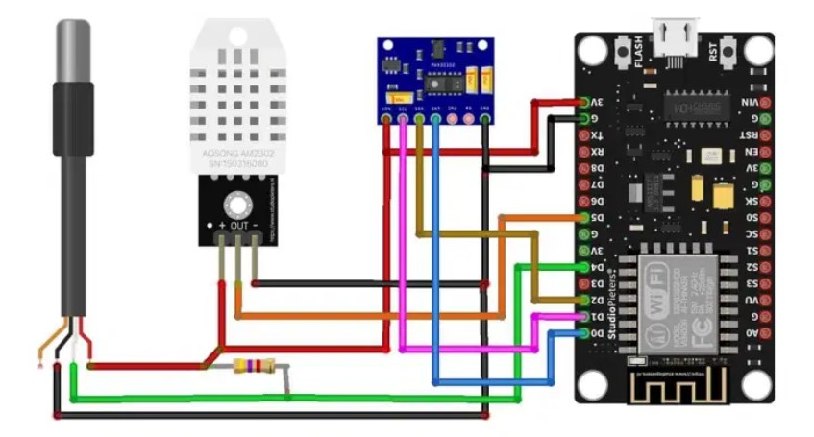**2.2 Circuit Diagram**

Figure: Circuit Diagram

**2.3 Block Diagram**

ESP8266 Wifi data transmission

NodeMcu ESP8266 module

Max 30100

Max sensor output

Temperature sensor LM35

LCD display

Power supply

Figure: Block Diagram

#### Figure labeling

###### **Pulse Sensor (MAX30100)**

###### MAX30100 is a sensor that can measure blood oxygen saturation level and pulse rate. Figure shows the prototype of the SpO2 Pulse Sensor (MAX30100). Saturation of peripheral oxygen (SpO2) is a calculation of blood vessel oxygen saturation, which refers to the amount of oxygenated hemoglobin in the blood. In a human body, ordinary SpO2 values range from 90to 100%. In this system, a MAX 30100 pulse oximeter was suitable. It is a coordinated beat oximeter and heart rate sensor arrangement, which provides precise values. This sensor combines two LEDs, a photo detector, optimized optics, and low-noise analog flag handling to identify beat oximetry and heart rate signals; hence, it is suitable for this system.

Fig. Max30100 sensor

1. **Node MCU**

We used the node MCU ESP8266 for this system, which is a wireless module, because the ESP8266 microcontroller has Wi-Fi capability, and the node MCU has a wireless system that can send data to a server. The node MCU has an asynchronous receiver-transmitter serial communication module, which enables it to communicate with the Bluetooth module. The node MCU ESP8266 microcontroller can operate with a power supply of 3.3 V operating voltage and a 7 to 12 V input voltage. It has a flash memory of 4 Mb and an SRAM of 64 Kb. It has 16 digital input and output pins and one analog input pin. The node MCU also has a PCB antenna. The node MCU wireless module sends the measured pulse rate, oxygen saturation, and temperature to the server. This component was chosen because it links the server IP address to the node MCU to obtain the measured value through a mobile application. The node MCU is an open-source Lua-based firmware and an advancement board. It is specially designed for IoT-based applications, and this component plays a vital role in our system. Figure shows 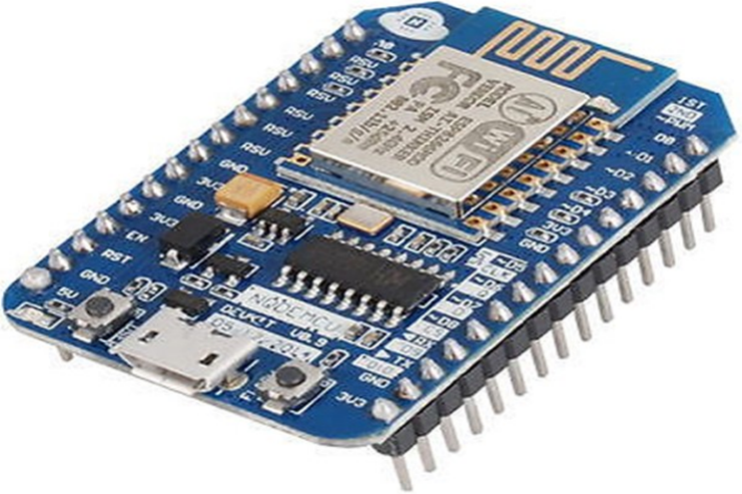the prototype of the node MCU ESP8266 microcontroller.

Fig. Node MCU ESP8266

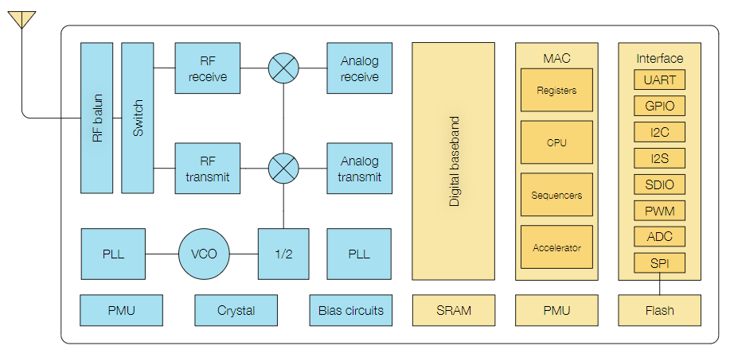

Figure: Functional Block Diagram

# 

# **3.** **DS18B20**

# This is a pre-wired and waterproof version of the **DS18B20**sensor. This sensor is useful for measuring temperature from -55°C to 125°C (-67°F to +257°F) even in wet conditions. It has a long wire, so it’s useful when a patient is a little far. Actually, the cable of this sensor is **jacketed in PVC.** DS18B20 is a digital sensor, so there is no signal degradation in long distances. It is fairly precise, i.e., ±0.5°C over much of the range. This sensor works great with any microcontroller using a single digital pin.

The downside is it uses the Dallas 1-Wire protocol, which is complex and requires a bunch of code to communicate.

# 

# 

# Fig the **DS18B20**sensor

# **4.DHT – 22**

# The DHT22 is a simple, ultra-low-cost digital temperature & humidity sensor. DHT22 uses a capacitive humidity sensor and a thermistor to measure the surrounding temperature and humidity. It sends data in digital signal form so no analog input pin is required.

# 

# CHAPTER 4

### Implementation & Testing

### Working

### Under the implementation part there are various fundamentals one of them is working of the project in a synchronized manner as project contains various fundamentals below is the process for the same.

### 1} Initiation of the project starts with the very first things is giving the power to the circuit as our micro controller for the project is NodmcuEsp8266 which is a communication based device

### 2}After turning the power on there are functions of 3 Sensors one is Max 30100 , second is DHT 22 and thirdly DS18B20

### Max sensor is a multifunction device that measures the both Oxygen (Spo2) and Bpm

### 3}The major part of the circuit is having connectivity between the Nodmcuesp8266 and the web server so that the data Read by the above mentioned 3 sensor is easily transmitted and displayed at the user

### 4}For that we have initiated a Ajax named developed syntax formation which provides a IP for the certain data on the Serial monitor and then later the data is displayed on that Ip address with a html based data created on the same

### 5}In the code we also added the html file required for receiving and reading of the data for Nodmcuesp8266.The data received if then transmitted and received at the user side on any machine

### 6}The transmission for the transmission of the data from the nodmcu to the server the 3 things are necessary as they are the required data for the micro controller (SSID), (Password) – of the users wifi or data connectivity (Ip address assigned by the Nodmcu)

* PCB Greber file Schematic

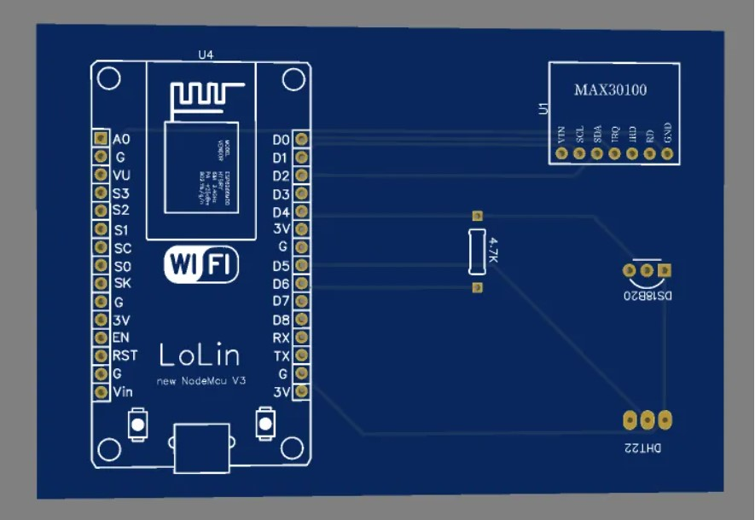

* Demonstration

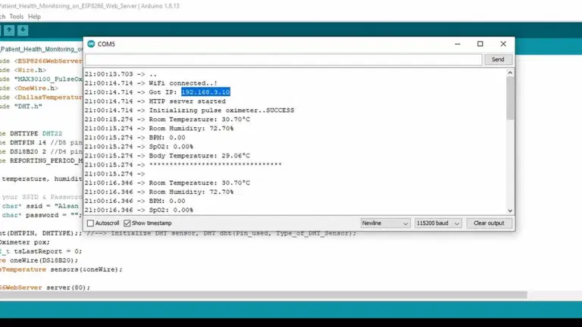

1) Once the code is uploaded to your NodeMCU ESP8266 board, you can open the serial monitor to see the program into action. The NodeMCU ESP8266 will connect to your Wi-Fi Network. Once connected, it will display the**ESP8266 IP Address.**

**2)** Now, copy the **ESP8266 IP Address** and paste it on your **Web Browser**. It will display the room temperature, room humidity, Heart Rate, Blood Oxygen Level, and body temperature, etc., as shown in the images below.

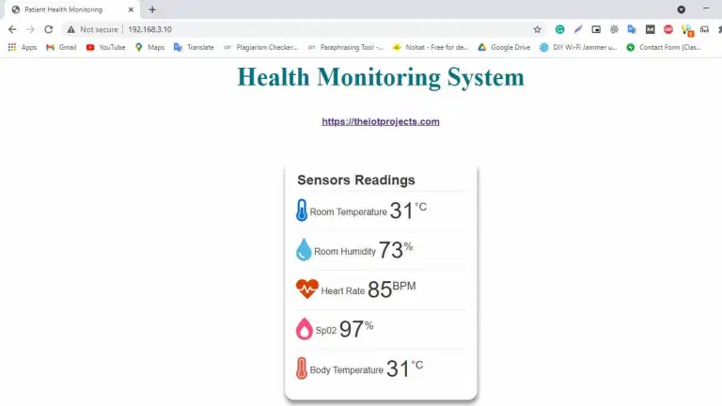

3)Similarly, you can monitor your patient’s health from any device that features **browsing capability**. The below image is the view of the **Patient Health Status** on **Android Smart Phone**. You simply need to copy the IP Address and paste it on the browser of **any device**.

**Conclusions**

# CHAPTER 5

The COVID-19 pandemic has resulted in a global health crisis as thousands of people die from the disease every day. The fatality rate can be minimized if proper treatment is administered at the right time. Various steps, including regular monitoring of pulse rate, and temperature, have been taken to ensure proper treatment. However, the oxygen level of a COVID-19 patient decreases with time, and the patient can die shortly if emergency steps are not taken. Considering the abovementioned facts, an IoT-based smart health monitoring system was developed for COVID-19 patients. The system runs through an IoT-based application, and both the doctor and the patient can receive alerts from this system during emergencies. Therefore, individuals can use this system effectively anywhere. Advanced features can be added in the future because the entire system is IoT-based.

Moreover, this study broadly explores the components utilized within the system and the usefulness of each component. It provides a list of strategies that can be actualized to plan this system. From the beginning of the development of this system, we aimed to develop a well-organized application-based device that could be used in the current pandemic. COVID-19 patients and people enduring numerous other infections like chronic obstructive pulmonary disease (COPD) and asthma can use this gadget. The system is cost-effective, non-invasive, and versatile in nature, which makes it easier to screen patients’ well-being regardless of where they are. Additionally, it provides real-time alerts to concerned individuals and medical experts about any circumstance that requires prompt consideration. This system can offer assistance to guarantee appropriate medical care all over Bangladesh, including in rural zones, thereby decreasing the number of patients. To conclude, this system is extremely important in the medical sector because it can help increase the life expectancy of people worldwide. In the future, more sensors can be added to this system to monitor more physiological parameters of the human body.

# **Future Scope**

IoT efﬁciently links patients, clinics, doctors, and hospitals to organize and orchestrate diagnosis and treatment across a wide variety of locations. During the pandemic, data protection and conﬁdentiality are the key concerns with healthcare systems because it passes across the unsecured system. The patient ‘scare record which is made up of personal records, clinical conditions, diagnosis results, and associated medications, which considered sensitive data. Hackers may change the health-related details resulting in misdiagnosis, or incorrect disease assessment leading to unsuitable treatment, thus increasing the rate of mortality. Medical data transmission tracked through IoT devices is vulnerable to security concerns.

IoT is considered as one of the main sources to collect a huge amount of data. With the huge collected data of patient’s records, researchers have to pay attention to storage, access, transportation, and processing of the huge amount of data they will produce.

Visualization is needed to provide complex outputs so that the COVID-19patients can easily use and learn. So that the analysis of patient’s data can be computed as outputs or use outputs from statistical analysis and transform them into visualization.14. IoT applications involve frequent COVID-19 patient’s data transmission from them and other things to a cloud, such process quickly drains battery capacity on both the things and the gateway. Therefore, energy efﬁciency in both data processing and transmission is an important open problem

# References

<https://www.hindawi.com/journals/cmmm/2021/8591036/>

<https://ieeexplore.ieee.org/document/8441708>

COVID-19 Second Wave. Thailand Medical News,” <https://www.thailandmedical.news/news/second-wave-record-11,005-covid-19-deaths-in-last-24-hours,-cases-surging-everywhere-from-europe,-japan,-india,-u-s-,-russia,-malaysia-excepthailand?fbclid=IwAR1Ne1WS6YeqtJWfzfS30V0p3Arp9MciXsCfMrnRfsOofFlFXwZZINtAK6U>.

“Pulse Oximetry Training Manual. World Health Organization,” 2011, <https://www.who.int/patientsafety/safesurgery/pulse_oximetry/who_ps_pulse_oxymetry_training_manual_en.pdf?ua=1>.